| **Computing Fundamentals & Programming**  ***Section*: BSCE2021 Assignment # 11 *Total marks*: 100**  ***Name*** : ***____________________ Roll number* : _____________________** |
| --- |

***Submission:***

• *Email instructor or TA if there are any questions. You cannot look at others’ solution or use others’ solution, however, you can discuss it with each other. Plagiarism will lead to a straight zero with additional consequences as well.*

*• Submission after due time will not be accepted.*

**TASKS:**

**Q1** Write a program that does the following, report your output and also explain it:

**i)** declare an integer x and y

Give both of them values in the range of 0 to 19

Check if x is less than 20

If true Add the value of x into y and display the new value

**ii)** declare an integer x and y

Give both of them values in the range of 0 to 19

Check if x is less than 20

If true Add the value of x into y and display the new value

Else subtract the value of x from y and display the new value

**iii)** In your code in part i) place a semicolon ( ; ) after the if condition.

**iv)** In your code in part ii) place a semicolon ( ; ) after the if condition.

**v)** Print a reverse sequence of 50 numbers starting from i = 100 in a while loop.

e.g 100, 96, 92, 88 …...

**vi)** In your code in part v) place a semicolon ( ; ) after the loop condition.

**vii)** int x = 1;

while(x <= 10)

{

int x =0;

x++;

cout<< x;

}

What errors do you get from this code? How many times do you have to run this loop?

OUTPUT:

// this loop will run infinitely as the value of x is automatically zero in every loop

//so it will print 1 infinte times

**vii)**

int b = 200;

b = b * 10;

{

int x =0;

x++;

cout<< x;

}

cout<<x;

What errors do you get from this code? What output do you get? Explain.

OUTPUT:

//there is an error that x is not declared

**Q2**  i. Declare a variable x giving it an initial value of 1.

ii. Print 10 consecutive numbers starting from x

iii. Double x

iv. Repeat from 2. A total of 5 times.

**Q3** Write a program that outputs the factorial of the first 10 numbers starting from 1

**Q4** Write a program that takes number input into an int array of size 3. Your program should square these numbers and output them.

You are to repeat the process with fresh values for your array till the user enters -111.

**Q5** Print a multiplication table as follows

1 2 3 4 5 6

2 4 6 8 10 12

3 6 9 12 15 18

4 8 12 16 20 24

Again the number of columns and rows is taken from the user.

In this example the column size entered is 6 and the number of rows is 4.

CODES ARE: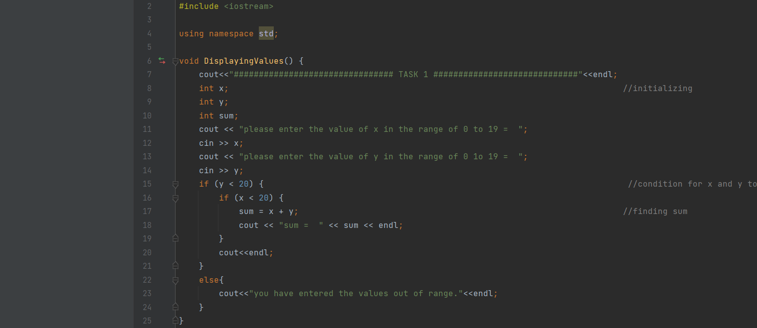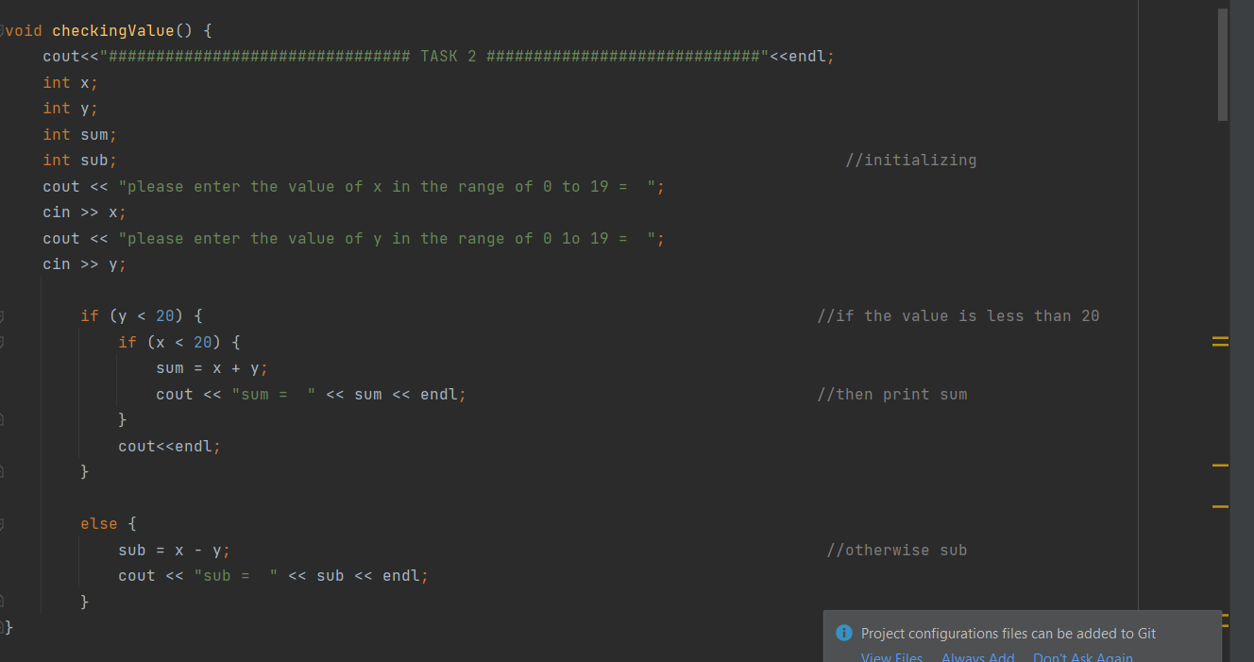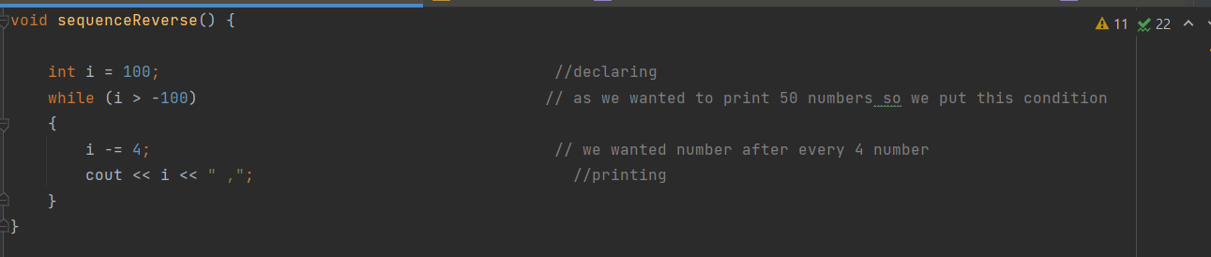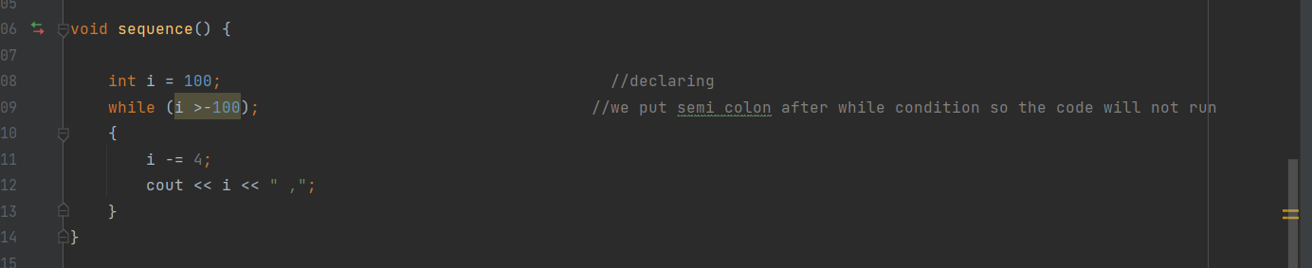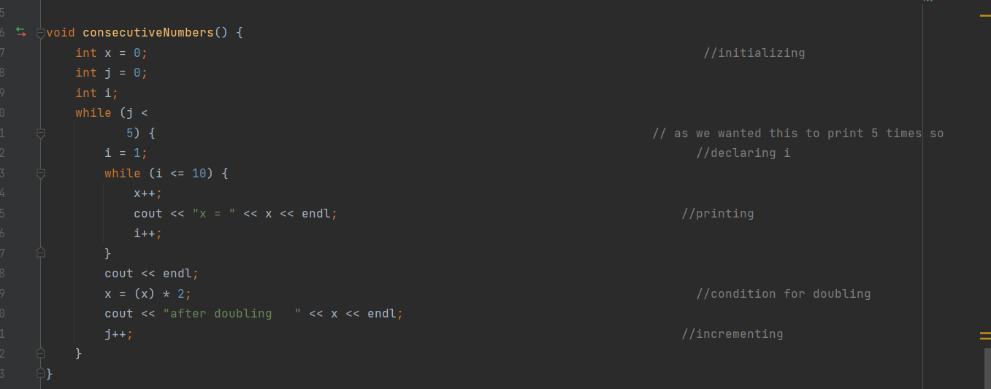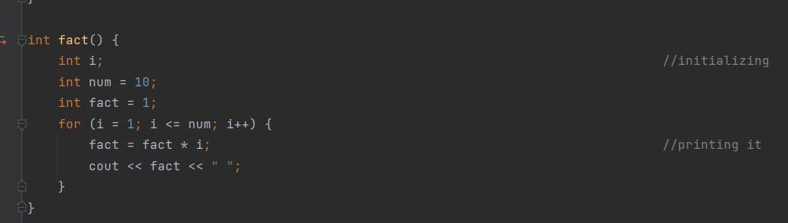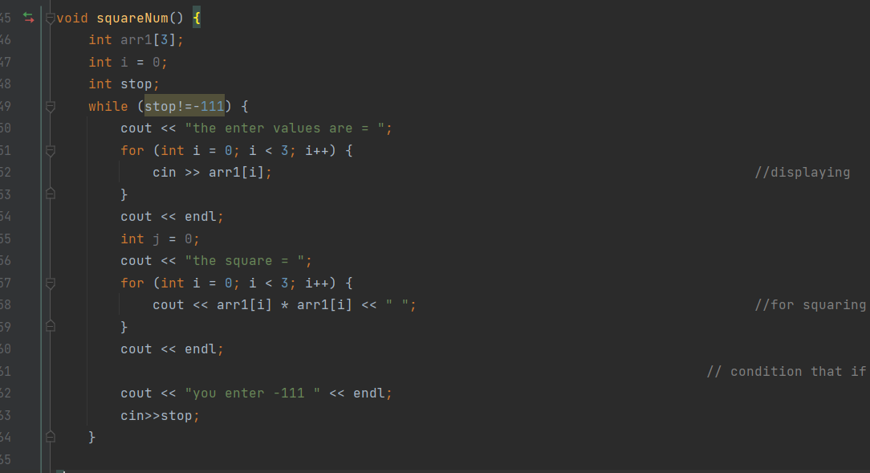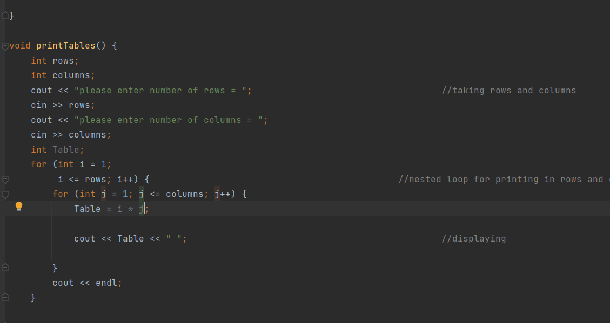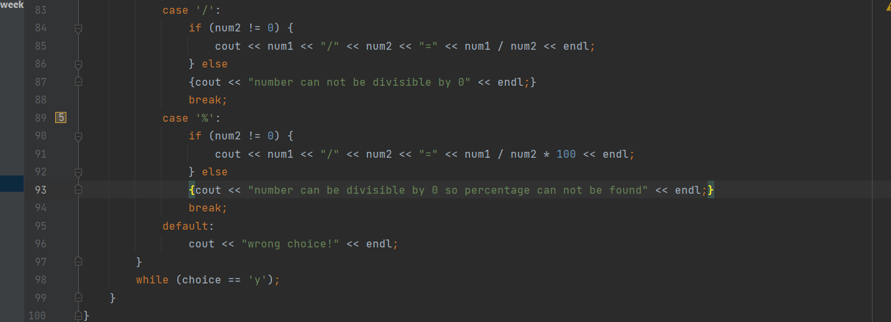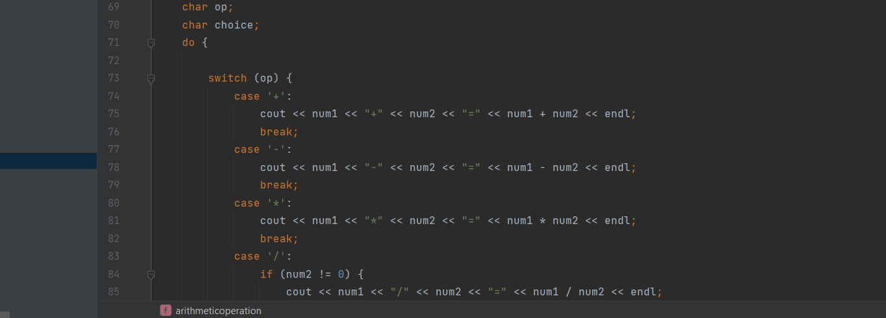

OUTPUTS ARE:

